IntervuIQ

A PROJECT REPORT
for
Major Project-I (CA205P)
Session (2025-26)

Submitted by

Kiran Yadav
(202410116100102)
Khushi Kumari
(202410116100101)
Khushi Bora
(20241011610098)
Kartikey Dwivedi
(202410116100099)

Submitted in partial fulfilment of the
Requirements for the Degree of

MASTER OF COMPUTER APPLICATION
Under the Supervision of
Dr. Prashant Agarwal

Professor



Submitted to
Department Of Computer Applications
KIET Group of Institutions, Ghaziabad
Uttar Pradesh-201206

(december- 2025)

CERTIFICATE

Certified Kiran Yadav (202410116100102), Khushi Kumari (202410116100101), Khushi Bora (20241011610099), Kartikey Dwivedi (202410116100098) has/ have carried out the project work having “IntervuIQ” (Major Project-I, CA205P) for Master of Computer Application from Dr. A.P.J. Abdul Kalam Technical University (AKTU) (formerly UPTU), Lucknow under my supervision. The project report embodies original work, and studies are carried out by the student himself/herself and the contents of the project report do not form the basis for the award of any other degree to the candidate or to anybody else from this or any other University/Institution.

Dr. Prashant Agarwal Dr. Sachin Malhotra
Professor Dean
Department of Computer Applications Department of Computer Applications
KIET Group of Institutions, Ghaziabad KIET Group of Institutions, Ghaziabad

IntervuIQ
Kiran Yadav, Khushi Kumari, Khushi Bora , Kartikey Dwivedi
ABSTRACT
In the modern recruitment landscape, candidates often participate in numerous interviews but fail to maintain a structured record of their experiences. This lack of organization leads to repeated mistakes, limited self-reflection, and missed chances for growth. Traditional methods such as manually tracking interviews, analyzing resumes, and writing cold emails are time-consuming and inefficient. To address these issues, this project introduces IntervuIQ, an AI-powered platform designed to streamline interview preparation and performance analysis.
IntervuIQ provides users with the ability to log job profiles, record interview rounds, document received feedback, and highlight personal areas of weakness. By leveraging AI capabilities, the system generates tailored preparation strategies, identifies resume gaps in relation to specific job descriptions, and automates professional cold emailing. Furthermore, it allows users to maintain both private and public repositories of interview questions, fostering knowledge sharing while supporting confidentiality.
The platform is designed with a user-friendly interface and modular approach, ensuring accessibility and efficiency for candidates at different career stages. Through personalized insights and intelligent recommendations, IntervuIQ empowers users to enhance their preparation process, build confidence, and increase their chances of cracking future interviews. Ultimately, this project contributes to improving employability by reducing manual effort, saving time, and providing structured self-analysis supported by artificial intelligence.
Keywords: Interview Tracking, AI in Recruitment, Resume Gap Analysis, Cold Email Automation, Career Preparation

ACKNOWLEDGEMENTS

Success in life is never attained single-handedly. My deepest gratitude goes to my project supervisor Dr. Prashant Agarwal for her guidance, help, and encouragement throughout my project work. Their enlightening ideas, comments, and suggestions.Words are not enough to express my gratitude to Dr. Sachin Malhotra, Professor and Dean, Department of Computer Applications, for his insightful comments and administrative help on various occasions.
Fortunately, I have many understanding friends, who have helped me a lot on many critical conditions.Finally, my sincere thanks go to my family members and all those who have directly and indirectly provided me with moral support and other kind of help. Without their support, completion of this work would not have been possible in time. They keep my life filled with enjoyment and happiness.

Kiran Yadav
(202410116100102)
Khushi Kumari
(202410116100101)
Khushi Bora
(20241011610099)
Kartikey Dwivedi
(202410116100098)

TABLE OF CONTENTS

Certificate
Abstract
Acknowledgements
Table of Contents
1 Introduction 7-10
  - Overview
    - Motivation
    - Objective
  - Significance of the Study
    - Academic Significance
    - Industrial Significance
  - Research Methodology
  - Limitation
- Feasibility Study/Literature Review 11-13
  - Technical Feasibility
  - Economic Feasibility
  - Operational Feasibility
  - Literature Feasibility
  - Legal and Ethical Feasibility
- Project/ Research Objective 13-16
- Hardware and Software Requirements 17-19
- Project Flow/ Research Methodology 20-22
- Project/Research Outcome 23-27
  - Overview
  - Achieved Outcomes
  - Technical Outcomes
  - Learning Outcomes
  - Future Scope
  - Conclusion
- Project Output 28-32
8 References/ Biblography 33
CHAPTER 1

INTRODUCTION

1.1 Overview
Securing a job in today’s competitive environment requires multiple stages of preparation and repeated interview attempts across various companies. However, one of the common challenges faced by job seekers is the lack of a centralized system to record and analyze their interview experiences. Without proper tracking, candidates fail to recognize patterns in their mistakes, identify skill gaps, or improve their answers for future opportunities.
Additionally, essential tasks such as tailoring resumes for specific job descriptions, drafting professional cold emails to recruiters, and reflecting on feedback consume valuable time. This reduces the time available for focused preparation and skill development.
To address these issues, IntervuIQ has been developed as a smart, AI-powered platform. It integrates multiple modules, including job tracking, resume gap analysis, feedback assessment, cold email automation, and AI-based preparation guidance. This ensures that candidates spend less time on repetitive manual work and more time on effective preparation.

1.1.1 Motivation
The motivation behind developing IntervuIQ lies in the increasing complexity of job preparation processes. Candidates today:
- Struggle to track past interviews in an organized way.
- Often overlook recruiter feedback and repeat the same mistakes.
- Submit resumes that do not align with specific job descriptions.
- Spend excessive time drafting professional recruiter emails.
These challenges highlight the need for a structured, AI-powered system that transforms each interview into a learning opportunity.

1.1.1.1 Problem Statement
We give thousands of interviews while searching for jobs, but rarely keep track of them in one place. This makes it difficult to analyze what went wrong, what skills we are lacking, or which answers need improvement. On top of that, the hectic process of sending cold emails and manually analyzing resumes takes valuable time that could otherwise be invested in focused preparation.

1.1.1.2 Solution Approach
IntervuIQ addresses these challenges by offering:
- A centralized dashboard to record and visualize interviews.
- AI-driven insights for strengths, weaknesses, and learning recommendations.
- Resume gap analysis to compare resumes with job descriptions and suggest improvements.
- Cold email automation to draft professional recruiter emails.
- A question bank module for personal or community-driven learning.
- An AI preparation guide that generates personalized strategies and tracks progress.
By integrating these modules, the platform ensures that candidates can prepare smarter, faster, and more effectively.

1.1.2 Objectives
The objectives of IntervuIQ are:
- To centralize interview experiences into one organized system.
- To provide personalized AI-based insights for continuous improvement.
- To align resumes with job requirements through automated analysis.
- To reduce preparation time by automating recruiter communication.
- To build a community-driven knowledge base of interview questions.
- To deliver a personalized preparation roadmap with measurable progress.

1.1.2.1 Scope of the Project
The project scope includes:
- User authentication and personalized dashboard.
- Job profile tracking with company, job title, and feedback details.
- Feedback and self-assessment analysis.
- Resume gap analysis with alignment reports.
- Cold email generation for recruiter communication.
- Public and private question bank.
- AI-driven preparation guidance and progress tracking.

1.2 Significance of the Study
1.2.1 Academic Significance
The project demonstrates real-world application of Artificial Intelligence, Natural Language Processing, Web Development, and Database Management. It provides students and researchers with an opportunity to study the integration of modern technologies into career development systems.
1.2.2 Industrial Significance
From an industry perspective, IntervuIQ ensures that candidates are better prepared and aligned with job requirements. This results in improved recruitment efficiency, reduced hiring costs, and higher quality of selected candidates.

1.3 Research Methodology
The methodology adopted for developing IntervuIQ involves:
- Requirement analysis.
- System design using architecture and workflow diagrams.
- Module implementation with AI and web technologies.
- Testing for accuracy, usability, and functionality.
- Deployment for user access.
- Continuous improvement based on user feedback.

1.4 Limitations
- Requires stable internet connectivity.
- AI accuracy depends on input data quality.
- Resume analysis may vary depending on formatting.
- Cold email effectiveness depends on recruiter response.
- Focus is limited to interview preparation, not direct placement.
CHAPTER 2

FEASIBILITY STUDY / LITERATURE REVIEW

2.1 Technical Feasibility
The IntervuIQ platform is technically feasible because it is based on proven web and mobile technologies. By using frameworks such as React, Node.js, and cloud-based storage, the platform can efficiently handle user data, track interviews, and generate insights. Integration with AI models for resume analysis and feedback ensures automation and accuracy. Existing APIs for job boards, email services, and calendar integrations can be utilized to reduce development effort. Hence, the required technology stack is both available and reliable.

2.2 Economic Feasibility
The solution is cost-effective compared to the problem it addresses. Job seekers often spend money on coaching, resume services, and interview preparation, yet still lack a centralized system for tracking progress. IntervuIQ minimizes manual effort and saves time by providing everything in one platform. Initial costs may involve server hosting, development, and cloud services, but the long-term benefits include subscription-based revenue models and partnerships with recruitment firms. The overall return on investment (ROI) is expected to be positive, making the project economically viable.

2.3 Operational Feasibility
From the user’s perspective, the system is highly practical. Users can log interviews, store resumes, track feedback, and analyze performance in a user-friendly interface. Automation reduces manual tasks such as sending cold emails or tracking skill gaps. Since users are already familiar with digital platforms (like LinkedIn, job portals, and Gmail), adoption of IntervuIQ would be smooth. Additionally, recruiters and mentors can use the system to provide structured feedback, making it operationally strong and sustainable.

2.4 Literature Review
Several existing tools address parts of the job-seeking problem but lack an integrated solution.
- LinkedIn focuses on professional networking but does not track interview performance.
- Job portals (e.g., Naukri, Indeed, Glassdoor) allow job applications but lack personal analytics.
- Resume analyzers provide keyword matching but fail to integrate with real-time interview data.
- Interview coaching platforms offer practice questions but lack automated tracking.
IntervuIQ bridges these gaps by combining interview tracking, resume analysis, AI-driven feedback, and performance monitoring into a single smart platform. This makes it unique compared to fragmented existing solutions.

2.5 Legal and Ethical Feasibility
Since the system involves handling personal and sensitive data (resumes, interview details, company names, and skills), compliance with data protection laws (GDPR, IT Act in India) is mandatory. Ethical feasibility is ensured by maintaining user privacy, transparency, and consent-based data sharing. The system will encrypt sensitive data and only share it when users allow, ensuring trust and security.

CHAPTER 3

PROJECT / RESEARCH OBJECTIVES

In today’s world, getting a good job is not just about having the right qualifications — it is about standing out, staying prepared, and constantly improving with every opportunity that comes your way. As students about to enter the professional world, we have experienced firsthand the stress and uncertainty that come with job hunting. Each of us has appeared for multiple interviews, and while every interview gave us new insights, we often found ourselves repeating mistakes or forgetting key lessons from earlier attempts.
This observation planted the seed for IntervuIQ, an AI-powered platform that helps candidates track, reflect on, and improve their interview performance. The journey of creating this project began with a very simple question: “Why do we treat every interview as an isolated event when each one can be a stepping stone toward the next?”

3.1 Why We Felt This Project Was Needed
Interviews are much more than just answering questions — they are opportunities to showcase our skills, understand industry expectations, and learn from feedback. Yet, most candidates walk away from interviews with only vague memories of what went well and what did not. There is no structured way to capture feedback, analyze patterns, or track personal growth. This results in:
- Losing valuable lessons from each interview experience.
- Wasting time repeatedly preparing the same topics while ignoring real skill gaps.
- Struggling to tailor resumes for different job descriptions.
- Spending hours drafting professional emails to recruiters instead of practising for interviews.
We realized that while numerous tools exist to apply for jobs, none actually focus on helping candidates learn from their interviews. There is LinkedIn for networking, Naukri and Indeed for job listings, resume analyzers for keyword matching, and coaching platforms for mock interviews — but not a single place to combine these learnings into a personal growth journey. This gap became the foundation of our project objective.

3.2 What We Aim to Achieve with IntervuIQ
Our primary objective is to build a centralized and intelligent interview companion that not only stores a candidate’s interview history but also learns from it to offer personalized guidance. We envision IntervuIQ as a personal mentor who:
- Tracks all your interviews in one clean, organized dashboard.
- Shows you what went wrong, what went right, and what can be improved next time.
- Reads your resume and matches it against job descriptions to spot missing skills.
- Helps you craft professional cold emails to recruiters in just a few clicks.
- Provides a private and public bank of interview questions that you and others can contribute to.
- Continuously refines your preparation roadmap based on your progress.
In essence, we are turning scattered experiences into structured growth through the power of AI and automation.

3.3 Breaking Down the Objectives
To make these ideas actionable, we divided our objectives into clear and measurable parts:
- Interview Experience Centralization
Provide a platform where candidates can log every interview — the company name, job title, interview rounds, feedback received, and their own reflections. This helps identify recurring mistakes and track performance trends.
- AI-Driven Insights for Continuous Improvement
Develop modules that analyze interview feedback and self-assessments to suggest tailored preparation plans, practice resources, and improvement strategies.
- Resume Gap Analysis
Create a system that compares a candidate’s resume with a given job description, highlighting missing skills, certifications, or keywords, and suggesting how to close those gaps.
- Cold Email Automation
Build a smart tool that drafts personalized recruiter emails, reducing the effort and anxiety of reaching out professionally.
- Community-Powered Question Bank
Enable users to maintain both private and public repositories of interview questions, building a collaborative knowledge base while respecting individual privacy.
- Personalized Preparation Roadmap
Combine data from interviews, resumes, and feedback to generate a dynamic preparation roadmap with measurable milestones, helping users see their growth over time.
These objectives ensure that IntervuIQ evolves into a comprehensive career preparation assistant rather than just another job portal.

3.4 The Bigger Purpose Behind Our Objectives
While each of the above objectives has a technical function, the heart of our project is deeply human. We want to make the job-hunting process less lonely, less confusing, and less overwhelming. Preparing for interviews can often feel like navigating a maze blindfolded — you keep trying, but you are never sure if you are heading in the right direction.
With IntervuIQ, we want to hand candidates a map. Not just a list of tasks, but real guidance built from their own experiences. We want them to see how far they have come, what challenges they overcame, and what steps to take next. We want them to walk into interviews with clarity, confidence, and a sense of control.
We also hope to encourage a culture of sharing and learning together. When users contribute their interview questions or share what they learned, they help others who might be struggling with the same fears. This builds a supportive community where everyone grows together instead of competing in isolation.

3.5 Long-Term Vision
Though IntervuIQ is currently a student project, our long-term vision is to develop it into a fully functional platform used by students, job seekers, career counsellors, and recruiters alike. In the future, we aim to:
- Partner with universities and training institutes to help students track placements.
- Collaborate with companies to streamline their recruitment feedback process.
- Integrate advanced AI models for real-time mock interviews and skill assessments.
- Evolve the system into a data-driven employability analytics tool.
By achieving our project objectives, we hope to contribute to a world where every candidate becomes more prepared, more confident, and more self-aware with each interview they face.
3.6 Summary
In short, the objective of our research and development effort is not merely to create software but to empower people. IntervuIQ is designed to reduce the stress of job preparation, turn interviews into learning opportunities, and give candidates the structure they need to succeed. It embodies our belief that technology should not replace human effort — it should amplify human potential.
Through this project, we are not just building a platform. We are building confidence, clarity, and career growth
CHAPTER 4

HARDWARE AND SOFTWARE REQUIREMENTS

Overview
This section details the hardware and software resources necessary to develop, test, and deploy the IntervuIQ application. Requirements are presented in two tiers — Minimum (development/test) and Recommended (development, testing & small-scale production) — and are followed by a breakdown of required software frameworks, libraries, third-party services, development tools, and supporting utilities. For each item a brief rationale is provided to justify the choice. 1. Hardware Requirements
1.1 Minimum Requirements
Processor: Intel i3 / AMD Ryzen 3 or equivalent
RAM: 8 GB
Storage: 256 GB HDD or SSD
Display: 1366×768 resolution or higher
Network: Stable internet connection
Explanation:
These specifications are sufficient for development, testing, and running the project locally. The application does not require high-end graphics or large storage capacity.
1.2 Recommended Requirements
Processor: Intel i5 / Ryzen 5 or higher
RAM: 16 GB
Storage: 512 GB SSD
Operating System: Windows 10/11 or Ubuntu 22.04 LTS
Network: High-speed broadband (10 Mbps or higher)
Explanation:
Recommended specifications improve performance while handling multiple tasks like running servers, databases, and browser-based testing simultaneously.

2. Software Requirements
2.1 System Software
Operating System: Windows 10/11 or Ubuntu 20.04+
Database: MongoDB 6.x
Server Environment: Node.js (LTS version)
Frameworks: Express.js (backend), React.js (frontend)
Language: JavaScript / TypeScript

2.2 Development Tools
IDE: Visual Studio Code
Version Control: Git and GitHub
API Testing: Postman
Package Manager: npm or yarn
Browser: Google Chrome or Microsoft Edge

2.3 Additional Tools and Libraries
Authentication: JWT, bcrypt
UI Design: Material UI or Tailwind CSS
AI / NLP Integration: OpenAI API or spaCy (for analysis modules)
2.4 Cloud & Deployment (Optional)
Hosting: AWS / Render / Vercel
Backup & Storage: MongoDB Atlas or Local MongoDB Server

SSL / Domain Management: Cloudflare or Let’s Encrypt

3. Summary
The IntervuIQ project requires a moderate configuration computer system with basic development tools and a modern browser. It is a cross-platform web application built using the MERN stack (MongoDB, Express, React, Node), making it lightweight, scalable, and deployable on both local and cloud environments.
CHAPTER 5
PROJECT FLOW / RESEARCH METHODOLOGY
The project IntervuIQ follows a structured workflow to ensure a smooth and intuitive experience for the end-user. The flow starts from user authentication and continues through multiple modules such as job tracking, feedback analysis, resume gap identification, AI-powered suggestions, and automated emailing.

5.1 User Access & Authentication
- Login/Signup Page
Users create an account using email and password or via OAuth (Google/LinkedIn).
During signup, minimal details such as name, email, and career field are collected.
After login, a personalized dashboard is generated.

5.2 Dashboard (Central Hub)
Displays:
- Summary of interviews attempted (job titles, companies, dates, rounds reached).
- AI Insights Panel – quick highlights of strengths, weaknesses, and pending tasks.
- Navigation Tabs for accessing modules:
  - Add Job Profile
  - Feedback & Self-Assessment
  - Resume Analysis
  - AI Preparation Guide
  - Cold Email Automation
  - Public/Private Question Bank

5.3 Job Profile Module
Input by User:
- Job title
- Company name
- Date of interview
- Rounds cleared
- Feedback received (if any)
- Personal notes on performance
System Processing:
- Stores data in database.
- Updates dashboard timeline.
- Triggers “Gap Analysis” if feedback includes weaknesses.

5.4 Feedback & Self-Assessment Module
Input by User:
- Areas where the user feels they lacked (e.g., coding skills, communication, domain knowledge).
- Feedback from interviewer (if remembered).
System Output:
- AI generates personalized strategies (study resources, practice areas, sample answers).
- Provides a skill improvement tracker to measure progress in future interviews.

5.5 Resume Gap Analysis Module
Input by User:
- Upload Resume (PDF/DOCX).
- Paste Job Description (JD) from portal/company.
System Processing:
- AI compares resume keywords with JD requirements.
- Identifies missing skills, certifications, or tools.
- Suggests improvements with sample phrases to add.
System Output:
- “Gap Report” highlighting what is present vs. missing.
- Ranking of resume alignment percentage with JD.

5.6 Cold Email Automation Module
Input by User:
- Target company name, recruiter details (if known), JD link.
System Processing:
- AI generates a personalized cold email based on user’s resume and JD gaps.
- Option to select formal/professional tone.
- Email preview shown to user.
System Output:
- Auto-drafted recruiter email that can be sent directly or downloaded.

5.7 Public/Private Question Bank Module
Input by User:
- Users can store questions they were asked in interviews.
- Option to mark as private (personal) or public (community shared).
System Output:
- Creates a searchable interview Q&A library.
- Public questions enrich the global database for peer learners.

5.8 AI Preparation Guide Module
Based on:
- Past interviews logged by user.
- Resume gap analysis results.
- Feedback & self-assessment.
System Output:
- Personalized preparation strategy (topics to focus on, suggested mock interviews, and resource links).
- A dynamic progress tracker shows improvement over time.

5.9 Overall Project Flow Diagram
User signs up → lands on dashboard.
Adds job profile → system saves & updates dashboard.
Logs feedback → AI generates improvement strategies.
Uploads resume + JD → AI identifies gaps.
Cold email module → generates recruiter outreach mail.
Question Bank → user adds/shares questions.
AI Preparation → suggests next steps.
User tracks growth over multiple interviews.

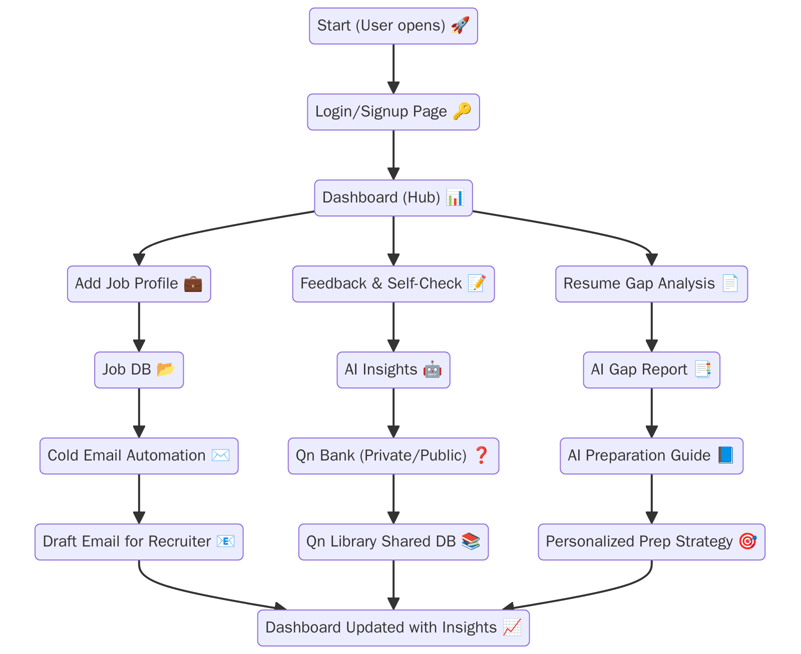

Flow Chart of IntervuIQ

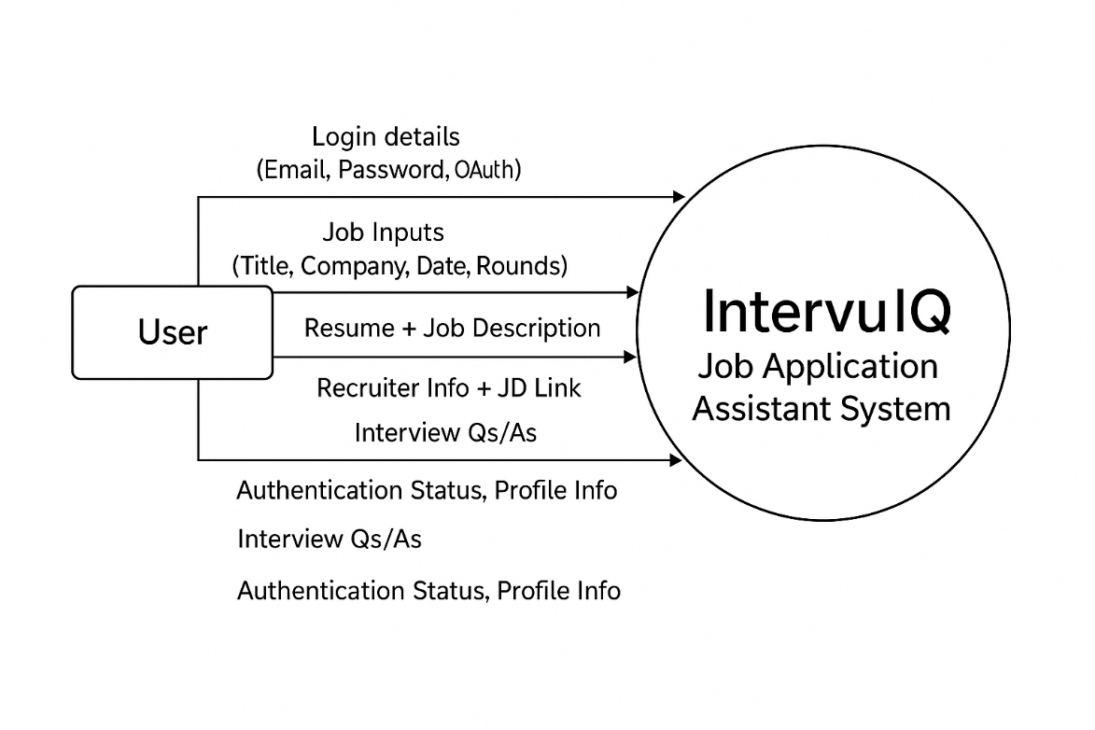
DFD Level 0 of IntervuIQ

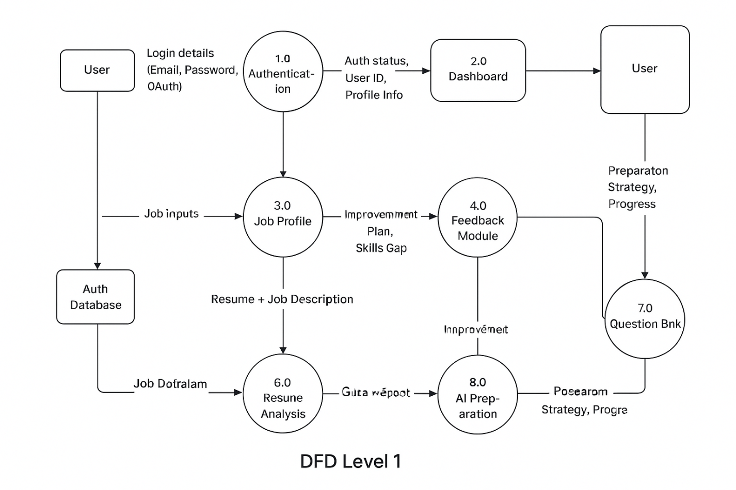

DFD Level 1 of IntervuIQ

CHAPTER 6

PROJECT/ RESEARCH OUTCOME

6.1 Overview

The successful completion of the IntervuIQ project represents a significant milestone in applying the principles of Artificial Intelligence (AI), Natural Language Processing (NLP), and Full-Stack Web Development to address a real-world challenge in the domain of interview preparation and career advancement. The project was conceptualized with the vision of helping candidates systematically record, analyze, and improve their interview experiences using intelligent automation.

The IntervuIQ platform provides an integrated environment that allows users to log their interviews, analyze feedback, compare resumes against job descriptions, automate recruiter communication, and generate AI-driven preparation strategies. Unlike conventional job portals that primarily focus on listings and applications, IntervuIQ emphasizes self-improvement through structured learning. By combining AI-powered recommendations with user-friendly interfaces, it simplifies the often-overwhelming process of interview preparation and reflection.

Through this project, the development team has successfully demonstrated how advanced technology can assist candidates in converting their interview experiences into data-backed insights for professional growth. The system not only supports individuals in their job-seeking journey but also introduces a scalable and extendable architecture suitable for academic and industrial applications.

6.2 Achieved Outcomes

The outcomes of the IntervuIQ project can be categorized into functional, technical, and analytical achievements.

1. Centralized Interview Tracking System

The system allows users to create detailed entries for every interview they attend. Each entry includes the company name, job profile, interview date, number of rounds, feedback received, and personal notes.
This centralization helps users identify recurring weaknesses, track performance trends, and monitor progress over time. The dashboard displays summaries of past interviews and upcoming goals, making self-assessment more structured.

2. AI-Based Feedback Analysis

One of the core features of IntervuIQ is the use of AI to analyze interview feedback and self-assessment inputs. The system interprets user reflections to generate personalized preparation strategies.
For instance, if a user reports weak performance in a technical round, the system suggests focused practice areas such as Data Structures, Algorithms, or Communication Skills. This transforms qualitative feedback into actionable insights.

3. Resume Gap Analysis Module

The resume gap analysis module enables users to upload their resume and paste a specific job description. The AI engine performs a keyword-based comparison between the two documents to identify missing skills, certifications, and relevant experience.
It produces a detailed “Gap Report” highlighting areas for improvement and calculates a “Resume–JD Match Score.” This feature helps users optimize their resumes for Applicant Tracking Systems (ATS) and align them with specific job postings.

4. Cold Email Automation

Writing professional recruiter emails can be challenging, especially for fresh graduates. IntervuIQ solves this by generating personalized, context-aware cold emails in just a few clicks. The system reads the user’s resume and target job description, then automatically drafts a formal and persuasive message suitable for professional outreach.
This feature saves time, ensures professionalism, and boosts response rates from recruiters.

5. Public and Private Question Bank

The platform supports both private and community-driven learning through its Question Bank module. Users can store the interview questions they encountered privately or choose to make them public for others’ benefit.
Over time, this builds a large, verified repository of interview questions categorized by company and domain, making the platform a rich source of shared learning.

6. AI Preparation Guide

The AI Preparation Guide uses data from all modules—interviews, feedback, and resume analysis—to generate a personalized preparation roadmap. It tracks the user’s growth over time, marks improvement areas, and suggests resources such as tutorials, coding platforms, and courses.
This module ensures continuous progress and helps users focus on what truly matters.

6.3 Technical Outcomes

From a technical perspective, the IntervuIQ project successfully integrates modern web technologies, backend systems, and AI-based components into a cohesive solution. The following outcomes were achieved during development:

- Designed and implemented a Full Stack MERN (MongoDB, Express.js, React.js, Node.js) architecture ensuring scalability and maintainability.

- Built secure RESTful APIs for data handling, user authentication, and module integration.

- Developed a responsive and interactive frontend interface using React.js and Material UI for a clean, modern user experience.

- Integrated AI/NLP-based analysis modules for feedback interpretation and resume–JD comparison.

- Ensured data security through password encryption, validation middleware, and protected routes.

- Adopted modular development practices, allowing future scalability and easier maintenance.

- Applied version control using Git and GitHub for collaborative development.

- Conducted extensive testing to validate system performance, user flow, and error handling.

- These outcomes demonstrate the team’s understanding of end-to-end software engineering—from conceptualization to deployment—while ensuring reliability, usability, and innovation.

6.4 Learning Outcomes

Working on IntervuIQ provided the team with an invaluable learning experience that extended beyond classroom concepts. Key learning outcomes include:

Practical Understanding of Full-Stack Development:
The project reinforced theoretical knowledge of front-end and back-end integration using JavaScript frameworks.

Experience in Artificial Intelligence and NLP:
Implementing AI-based modules helped the team understand the fundamentals of data processing, tokenization, and semantic similarity analysis.

Database Design and Management:
The use of MongoDB enhanced understanding of data modeling, document relationships, and indexing for performance optimization.

Project Management and Team Collaboration:
The team followed Agile methodologies, including sprint planning, task distribution, and iterative development cycles.

Enhanced Problem-Solving and Debugging Skills:
Developing and debugging the platform strengthened logical thinking and algorithmic design.

Exposure to Real-World Application Development:
The team learned how to translate user needs into system requirements and deploy solutions that offer measurable impact.

Overall, the project served as a bridge between academic learning and industrial software practices, preparing the team for real-world development challenges.

6.5 Future Scope

While the current version of IntervuIQ achieves its intended purpose, the project has significant potential for future enhancement. The following improvements are proposed:

LinkedIn Integration:
Allow users to directly import job profiles and recruiter connections from LinkedIn.

Mobile Application Development:
Extend the platform to Android and iOS for greater accessibility.

AI-Powered Mock Interviews:
Integrate a chatbot or voice-based interface to simulate technical and HR interviews with instant feedback.

Advanced Analytics Dashboard:
Offer visual insights into skill improvement trends, success rates, and preparation time analytics.

Recruiter and Mentor Portals:
Enable mentors to review student progress and provide structured feedback.

Data Privacy and Compliance Enhancements:
Include GDPR compliance checks, user consent controls, and advanced encryption for sensitive information.

Integration with Learning Platforms:
Automatically recommend relevant online courses based on skill gaps identified by the AI module.

These improvements will enhance system utility, scalability, and user experience, transforming IntervuIQ into a complete employability management system.

6.6 Conclusion

The IntervuIQ project successfully demonstrates how technology can be leveraged to improve employability and self-assessment. By combining AI insights with user-friendly interfaces, it enables candidates to convert every interview experience into a learning opportunity.

- The system empowers users to:

- Understand their strengths and weaknesses.

- Prepare strategically based on data-driven feedback.

- Save time through automation and smart recommendations.

- Build a knowledge base that benefits not only themselves but the larger job-seeking community.

In conclusion, IntervuIQ stands as a practical and innovative contribution to the evolving landscape of AI-based career assistance systems. It proves that with the right blend of technology and motivation, even a student-led project can create real impact in the world of recruitment and personal development.

CHAPTER 7

PROJECT OUTPUT

Login Page

The login interface allows registered users to securely access the system using their credentials. It validates input fields to ensure proper authentication. The “Forgot Password” option is available for account recovery. Upon successful login, users are redirected to their personalized dashboard.

This feature ensures data security and user privacy through encrypted authentication using JSON Web Tokens (JWT). It helps prevent unauthorized access, protecting sensitive data such as resumes and interview details.

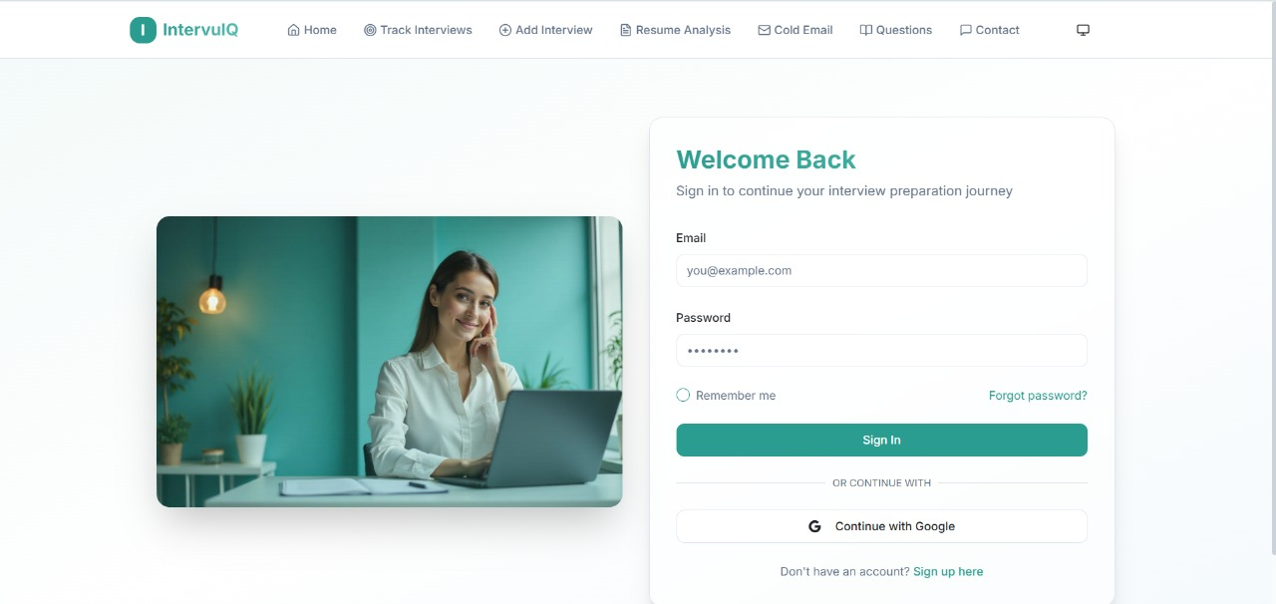

Signup Page
The Signup Page allows new users to register by entering basic details such as name, email, password, and career field. It verifies user information, sends a confirmation email, and securely stores credentials using encryption. Users can also sign up quickly using Google or LinkedIn accounts.

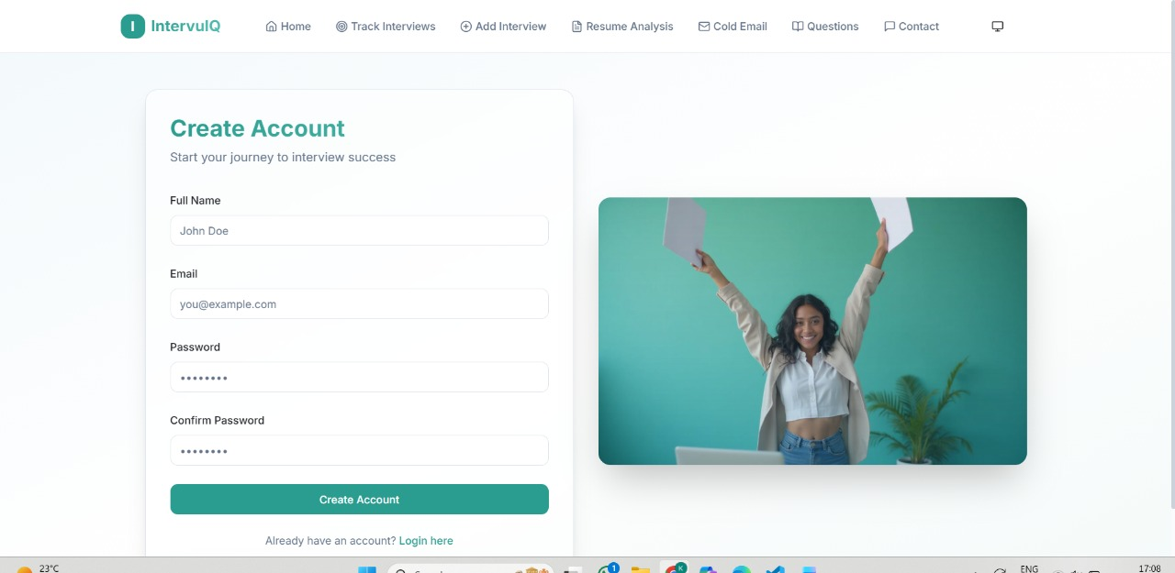

Homepage
The Homepage is the first screen users see when they visit IntervuIQ, giving them an overview of what the platform offers. It has a clean and modern design that clearly shows how the platform helps users track, analyze, and improve their interview preparation using AI.
The page includes an easy navigation bar with links to key sections like Track Interview, Add Interview, Resume Analysis, Cold Email, and Contacts. The main banner introduces the platform with short text and quick buttons such as “Get Started” and “Login / Sign Up.”

Advantages:
- Provides quick access to all important sections.
- Looks attractive, simple, and easy to use.
- Clearly explains the goal and benefits of the platform.
- Encourages users to start exploring right away.

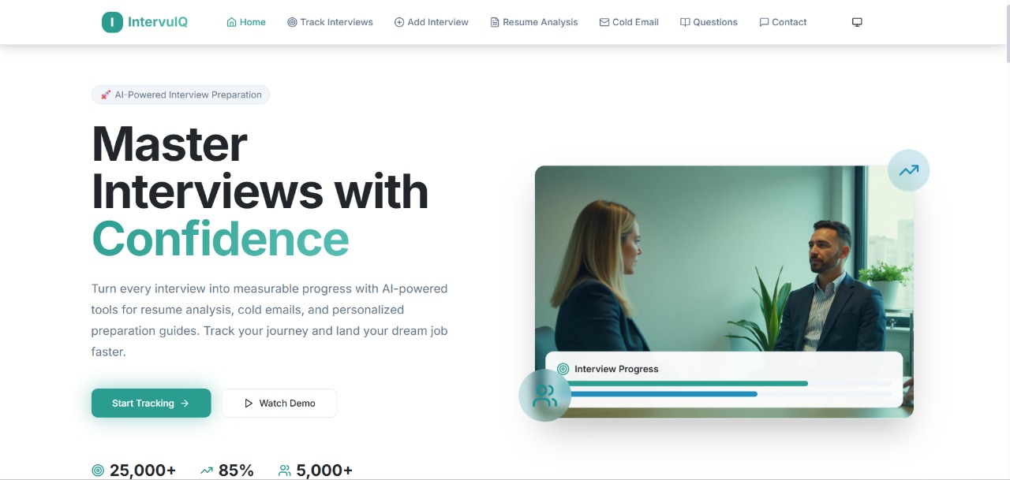

Track Interview Page
The Track Interview page enables users to maintain a detailed log of all interviews attended across different companies. Each record includes company name, job title, date of interview, number of rounds, feedback received, and user reflections.
The interface uses tables and cards to represent interviews, along with filters to view results based on company or performance. AI insights are displayed alongside, showing progress trends and recurring improvement areas.

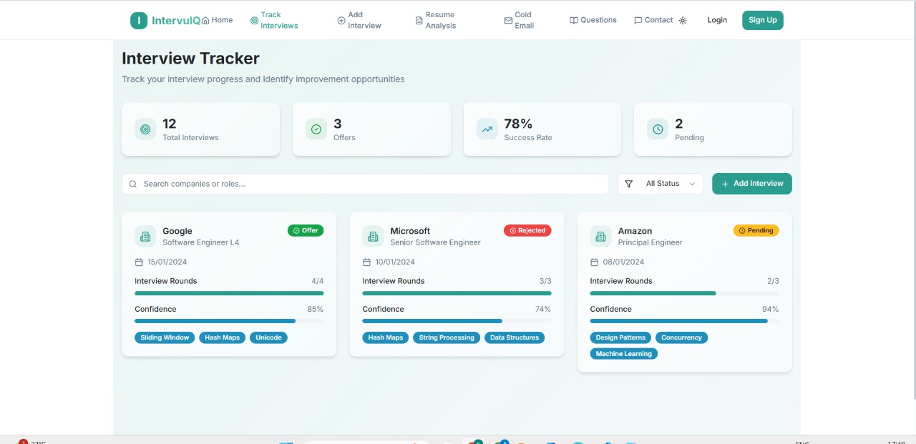

Add Interview Page
The Add Interview page allows users to input new interview details into the system. Users can fill in key fields such as job title, company name, interview date, rounds cleared, and feedback (if available).
Once submitted, the data is automatically stored and reflected on the dashboard and Track Interview page. This module also triggers AI-based feedback analysis if the user provides interviewer comments or self-assessment details.

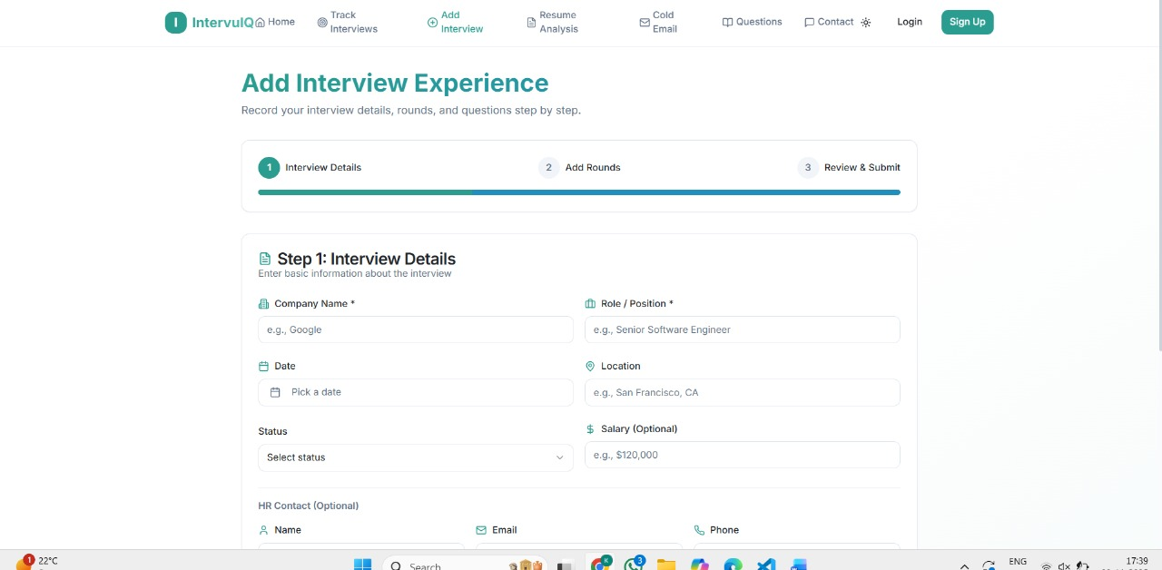

Resume Analysis Page
The Resume Analysis module allows users to upload their resume and paste a target job description. Using NLP-based keyword extraction and matching, the system identifies missing skills, certifications, and key phrases that are essential for better job alignment.
The output presents a Resume–JD Match Report, which highlights both present and missing skills. It provides a “Resume Match Score” (in percentage) to indicate how closely the resume aligns with the target role.
Advantages:
- Helps users identify gaps in their resumes before applying for jobs.
- Provides personalized recommendations to improve resume quality.
- Saves time spent manually tailoring resumes for each application.
- Increases the chances of clearing Applicant Tracking Systems (ATS) used by recruiters.

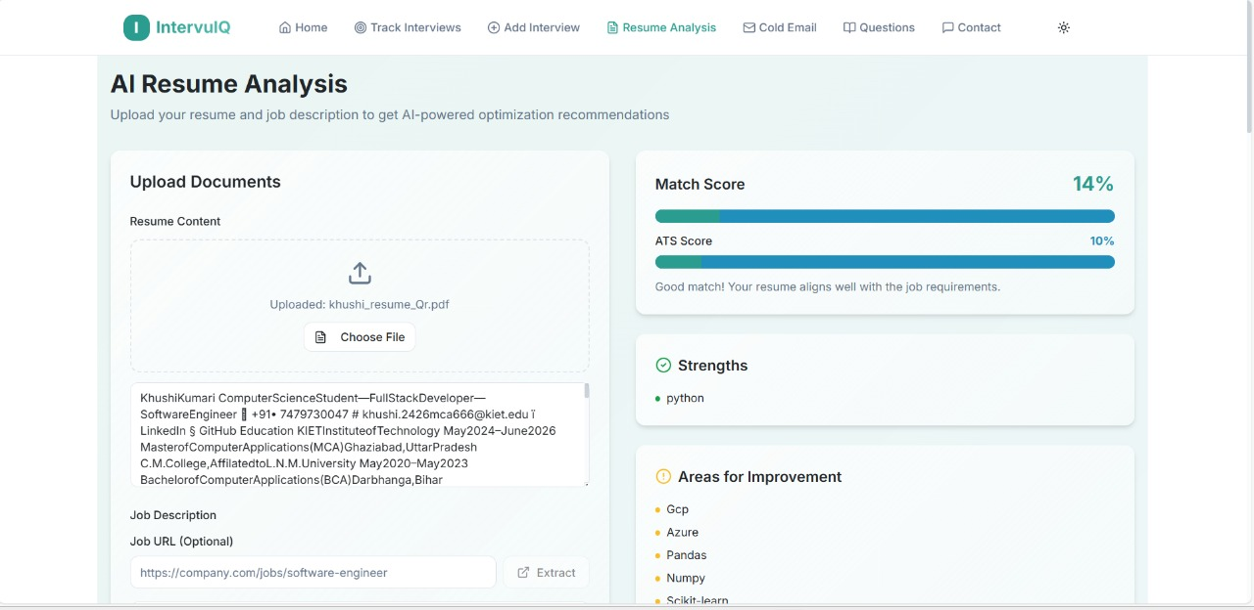

Cold Email Module
This module automates the process of writing professional recruiter emails. After analyzing the user’s resume and job description, it generates a personalized cold email tailored to the specific job role.
The email is written in a formal and concise tone, including the candidate’s introduction, core skills, and a call to action for further discussion. Users can edit, copy, or send the email directly from the interface.
Advantage
- Saves time by eliminating manual drafting of recruiter emails.
- Increases the professional appeal of outreach communication.
- Ensures consistency in tone and structure, enhancing first impressions.
- Helps candidates connect with recruiters faster and more confidently

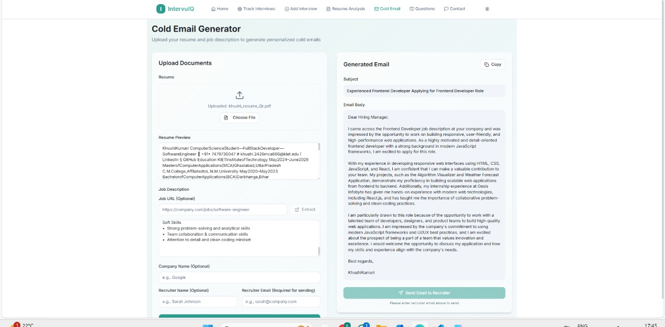

Questions Page
The To-Do Task module helps users organize their interview preparation activities. Users can create, update, and delete tasks related to study goals, interview schedules, or skill improvements.
The interface provides a simple and clear layout with options to mark tasks as completed. It visually represents the user’s preparation progress and encourages discipline in managing daily objectives.
Advantage
- Encourages structured preparation by organizing tasks effectively.
- Helps users maintain a consistent learning routine.
- Enhances time management and reduces last-minute stress before interviews.
- Provides a visual overview of preparation milestones, keeping users motivated.

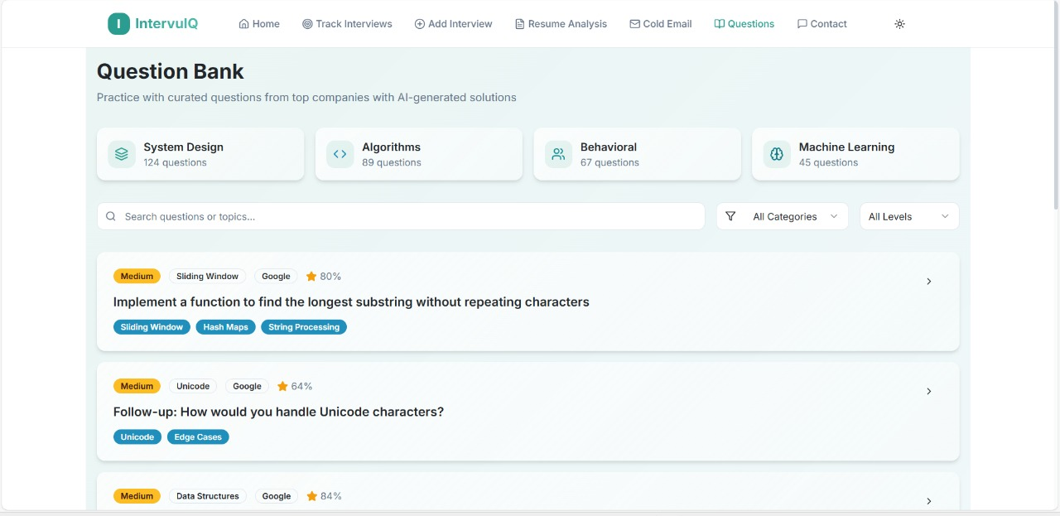

CHAPTER 8

REFERENCES / BIBLIOGRAPHY

- Sommerville, Ian. Software Engineering, 10th Edition, Pearson Education, 2019.
- Pressman, Roger S. Software Engineering: A Practitioner’s Approach, 8th Edition, McGraw Hill Education.
- Bhosale, N. & Mahale, A. (2020). AI in Recruitment and Selection: Trends and Challenges. International Journal of Computer Applications.
- Mozilla Developer Network (MDN) – React.js, Node.js, and REST API Documentation.
- W3Schools – Tutorials on HTML, CSS, JavaScript, and Web Technologies.
- OpenAI Developer Documentation – AI Text Analysis and NLP Concepts.
- Stack Overflow – Developer Community Discussions and Code References.
- GeeksforGeeks – Tutorials on MERN Stack, RESTful API, and AI Integration.
- GitHub – Public Repositories for Full-Stack Projects and Development Patterns.
- Oracle Documentation – Database Management and Query Optimization Techniques.
- AWS and Google Cloud – Cloud Deployment and Hosting Guidelines.
- LinkedIn Engineering Blog – Insights on Recruitment Automation using AI.
- Medium Articles – Research on AI-Based Career Preparation Tools and Trends.

